Bilingualism Effect for Delaying Dementia Onset: A Bayesian Meta-Analysis
Ziyuan Li*
Stefano Coretta
University of Edinburgh

Ziyuan Li, Department of Linguistics and English Language, 3 Charles St, University of Edinburgh, Edinburgh EH8 9AD, United Kingdom.
Stefano Coretta, Department of Linguistics and English Language, 3 Charles St, University of Edinburgh, Edinburgh EH8 9AD, United Kingdom.
*Correspondence concerning this article should be addressed to Ziyuan Li, Department of Linguistics and English Language, 3 Charles St, University of Edinburgh, Edinburgh EH8 9AD, United Kingdom. Tel: +8618031633636; E-mail: hka9peter@gmail.com

Abstract
Evidence suggests that lifelong practice of two or more languages may contribute to cognitive reserve and protect against dementia. Most retrospective studies comparing bilinguals’ and monolinguals’ age at dementia onset report a delay for bilinguals. However, some studies suggest that such protective effects may be specific to certain types of dementia. Meanwhile, several prospective studies which investigated whether bilingualism reduces the incidence rate of dementia produced null results. Therefore, we conducted the first Bayesian meta-analysis to examine the relationship between bilingualism and age at onset of dementia and bilingualism and the incidence rate of dementia respectively. The results from 18 age at onset studies revealed that bilinguals were, on average, 3.45 years older than monolinguals at symptom onset (95% credible interval [CrI]: [2.8, 4.1]). Moreover, the result was only slightly influenced by years of education, although the effect of education on dementia remains uncertain. The results from 6 incidence rate studies did not provide robust evidence for bilingualism’s preventive effect. Therefore, this meta-analysis demonstrated that bilingualism has potential effects in delaying the onset of dementia but not preventing it. Moreover, subgroup analyses revealed a relatively consistent pattern of delayed symptom onset among bilinguals, though the estimated delays differed across dementia types. However, due to the limited number of studies available for each dementia subtype, uncertainty remains regarding whether bilingualism induces differential effects across dementia types. This highlights the need for further research specifically targeting non-Alzheimer’s dementias to better clarify these potential differences.
Keywords: Bilingualism • Dementia • Alzheimer’s Disease • Bayesian Meta-analysis • Bilingualism Effect

Introduction
The aging adults may face an increasing risk of dementia, a syndrome resulting from a range of neurodegenerative diseases, as a result of deterioration of brain tissue (Mooij et al., 2018) and a loss of functional connectivity between regions (Brier et al., 2012). Such diseases affect language skills, memory and in later stages, bodily functions (Berkes & Bialystok, 2022; Homer et al., 1994). With the aging population and increased longevity of life, the prevalence of dementia also increases (Anderson et al., 2020; Berkes & Bialystok, 2022). According to the World Health Organization (2020), the total number of patients with dementia may rise to 82 million in 2030 and more than 150 million in 2050, which will bring enormous physical and psychological stress on both individual and societal levels. Unfortunately, it is still unclear how to prevent the pathology in aging adults (Kepp, 2016). While recent pharmacological advances, particularly anti-amyloid monoclonal antibody therapies, have shown significant results in double-blind, placebo-controlled phase III clinical trials (Budd Haeberlein et al., 2022; Sims et al., 2023; Van Dyck et al., 2023), the clinical meaningfulness, the long-term impact of these treatments and the actual therapeutic efficacy and accessibility for the real-world population are still under debate (Angioni et al., 2024). Consequently, exploring non-pharmacological contributors to cognitive resilience remains a crucial avenue of research. Several socio-behavioural factors may contribute to cognitive reserve, which helps individuals use compensatory mechanisms or functional processes to cope with neurodegeneration and pathology (Bialystok et al., 2007). These factors include education (Stern et al., 1999), complex social networking (Bennett et al., 2006), challenging occupational tasks (Stern et al., 2020), increasing physical activity (Sofi et al., 2011), and bilingualism (Bak, 2016; Jafari et al., 2021).
Recently, numerous studies have focused on the potential bilingualism effect on cognitive enhancements, including improved attentional control, working memory, metalinguistic and metacognitive awareness. Moreover, these enhancements resulting from bilingualism across the lifespan may contribute to cognitive reserve, which delays the onset of dementia for 4 to 5 years according to some retrospective studies (e.g., Bialystok et al., 2007; Craik et al., 2010). Yet, prospective studies revealed inconclusive results on bilingualism’s effect on reducing the risks of dementia (see Lawton et al., 2015 for null results; Zahodne et al., 2014 for positive results) while other retrospective studies showed a shorter delay of onset of dementia (e.g., 1.5 years: Berkes et al., 2020; 0.9 years: Chertkow et al., 2010). Previous meta-analyses also revealed inconsistent results. The meta-analysis by Mukadam et al. (2017) only included four prospective studies and found no evidence for the protective effects of bilingualism on dementia while Anderson et al. (2020) meta-analysis that included 15 age-of-onset studies and 6 incidence studies found moderate evidence for bilingualism’s delaying of symptoms (Cohen’s d = 0.32) and weak evidence for bilingualism’s reducing the incidence of having the Alzheimer’s disease (d = 0.10). Despite such inconsistency, one potential modulating variable, dementia types, has been neglected by previous meta-analyses. Lee (2022) pointed out that different subtypes of dementia seem to be deferred by different lengths of time in bilinguals compared with monolinguals. For instance, in Alladi et al. (2013), bilingualism’s delayed length of onset was 3.2 years, 6.0 years, 3.7 years, and 2.3 years for Alzheimer’s disease (AD), frontotemporal dementia (FTD), vascular dementia (VaD) and dementia with Lewy bodies (DLB). Therefore, it would be necessary to conduct a new meta-analysis to include more recent research and examine the effect of dementia types to better address the bilingualism-dementia link.

Mechanisms behind Bilingualism’s Effect on Dementia

Introducing Cognitive Reserve
Reserve in a broader sense refers to the individual variations in cognitive ability, clinical condition, and functional capacity in aging and brain disease, which indicates that specific conditions of brain health can lead to different cognitive or functional outcomes in different individuals (Berkes & Bialystok, 2022). Stern et al. (2020) stated that there are different types of reserve, namely brain reserve and cognitive reserve. The former refers to the neurobiological quality, such as cortical thickness, quantity of neurons, and total brain volume at a given point in time (Stern et al., 2020). Individuals with high brain reserve are supposed to better withstand aging and neurological decline since they have more tissue to lose. Such a passive model of reserve is impacted by genetic and lifestyle factors, and it does not invoke active cognitive adaptation (Stern et al., 2020). In contrast, cognitive reserve is thought of as an active reserve form which depends on individuals’ adaptability to cognitive processes (Berkes & Bialystok, 2022). As mentioned before, Individuals can adopt remedial mechanisms to better cope with aging and brain loss (Berkes & Bialystok, 2022). In this sense, there should be several outcomes when comparing high-cognitive reserve and low-cognitive reserve aging adults. At similar levels of neuropathology, high cognitive reserve individuals should show better cognitive performance than their low cognitive reserve peers. For individuals with similar cognitive performance, high-cognitive reserve individuals are expected to have more neuropathology than low-cognitive reserve individuals. Moreover, high-cognitive reserve individuals are expected to show delayed symptom onset compared with matched low-cognitive reserve individuals.
There are many factors that may contribute to cognitive reserve, which are limited by two prerequisites (Berkes & Bialystok, 2022). The first one is that these factors should be sufficiently challenging and continuous (Scarmeas & Stern, 2003). The second one is that individuals with higher levels of these factors or richer experience of the potential activities should show better cognitive condition. Thus, these factors should include both activities from early life, such as higher education and ongoing activities, such as challenging physical and mental activities (Stern, 2002, 2012).

Bilingualism as a Contributor of Cognitive Reserve
The use of multiple languages is considered a challenging activity since bilinguals have to constantly deal with the joint activation of both languages (Bialystok et al., 2012). Evidence for such joint activation is found by psycholinguists from cross-language priming, which is the facilitative effect of a word in one language on the retrieval of a semantically related word in another language (e.g., Thierry & Wu, 2007). This means that bilinguals have to select the appropriate language while inhibiting the others for effective language production, which allows bilinguals to possess better inhibitory control than monolinguals. Yet, Bialystok & Craik (2022) argue that inhibitory control is not enough to account for bilingualism’s enhanced cognitive function (EF) since dual language use involves not only inhibition but also facilitation of relevant processing, selection, and working memory. Despite different theories of explanation for the bilingualism effect, numerous empirical studies have shown that bilinguals outperform their monolingual peers on executive function tasks (e.g., Blom et al., 2014; Comishen & Bialystok, 2021). The “advantage” is generally more obvious in older adults with null results mostly found in younger adults who may reach the ceiling effect.
From the perspective of neuroscience, one explanation for bilinguals’ enhanced executive function may be that multiple language use reallocates the cognitive demand from anterior regions to posterior lobes and subcortical regions including the basal ganglia (Grundy & Anderson, 2017). The anterior lobes are typically believed to be involved in complex EF tasks, while posterior and subcortical regions are largely believed to be involved in automatic processing. Several neuroimaging studies have provided evidence for such a shift to improve neural efficiency in the bilingual brain. For instance, Abutalebi et al. (2015) used fMRI to record bilingual and monolingual brain signals when they performed flanker tasks. The results show that bilinguals showed better behavioural performance and that they recruited less anterior cingulate cortex (ACC) than monolinguals (Abutalebi et al., 2015). In Waldie et al. (2009), the fMRI results showed that Macedonian-English bilinguals possessed more activation in the basal ganglia area compared with monolinguals when they performed a Stroop task. Since the basal ganglia is a subcortical area that functions as a gate for anterior cortical regions, Waldie et al. (2009) also provide evidence for bilinguals’ reallocation of cognitive resources.
As adults age, their decreased automatic processing ability requires them to occupy the anterior lobes that are originally responsible for complex EF with simple tasks (Davis et al., 2008; Grady et al., 1994). This should at least partially account for older adults’ difficulty in performing complex tasks and declined cognitive function (Davis et al., 2008). Thus, bilingualism contributes to cognitive reserve by reallocating the cognitive demand from anterior regions to posterior and subcortical regions and sustaining the automatic process, which leaves space for complex EF.

The Limits of Bilingualism Effect on Dementia
Following the above argument, bilinguals who are high cognitive reserve individuals are supposed to better withstand neurodegeneration than monolinguals who are low cognitive reserve individuals. However, studies from different perspectives (prospective and retrospective) revealed different results, which indicates that there are limits to what bilingualism can do in terms of protection against dementia. The following part will briefly introduce previous studies and meta-analyses on the perspectives respectively.
As mentioned before, one important prediction from cognitive reserve is that individuals with high reserve will show a delayed onset of impairment compared to individuals with low reserve (Berkes & Bialystok, 2022). Retrospective studies compared the age of onset or diagnosis of dementia for both bilinguals and monolinguals in clinical samples. Bialystok et al. (2007) were the first to examine such effects on clinical populations with dementia. By examining the records of 184 patients with equivalent progression of Mini-Mnetal State Examination [MMSE; Folstein et al. (1975)] scores in Toronto Canada, they found that bilingual patients developed symptoms of dementia later than their monolingual peers for around 4 years (F (1, 178) = 9.16, p<0.003). The results have been replicated in different populations in various countries such as China (Zheng et al., 2018), India (Alladi et al., 2013), and Belgium (E. V. Y. Woumans et al., 2015). Given the mostly positive results of previous retrospective studies and the moderate effect (Cohen’s d = 0.32) of previous meta-analysis (Anderson et al., 2020), it seems that bilingualism’s delaying effect is less inconclusive than incidence rate studies.
Compared to retrospective studies, most prospective studies have a different outcome variable, the dementia incidence rate in certain populations (Grundy & Anderson, 2017). These studies track groups of healthy individuals and collect the rates of dementia in the groups during the study period. Yet, these prospective studies tend to find non-significant results of bilingualism’s preventive effects. For instance, Zahodne et al. (2014) followed a sample of 1067 old Spanish-English bilinguals and Spanish monolinguals in New York while collecting their cognitive test scores and clinical diagnoses every 18 to 24 months for approximately 20 years. At the end of the study, 31% of monolinguals and 20% of bilinguals had been diagnosed with dementia (Zahodne et al., 2014). The results showed that bilingualism was associated with a 0.291 lower log odds of incidence rates. After accounting for other predictors, bilingualism was not correlated with dementia risk despite attending higher education and being female being associated with lower dementia risk (Zahodne et al., 2014). Similarly, Lawton et al. (2015) and Ljungberg et al. (2016) also found no single correlation between reduced dementia risk and bilingualism in the US (x2(1, n=81) = .13, p = .72) and Sweden (bilinguals: Hazard Ratio = 1.43, 95% CI = 0.73 − 2.85, p = .29) respectively. Moreover, Mukadam et al. (2017) conducted a meta-analysis using only four prospective studies and found that bilingualism was not related to the protective effect of cognitive decline or dementia (Odds Ratio of dementia rates in bilinguals compared with monolinguals: 0.96 with a 95% CI [0.74 – 1.23]). They further argued that public health policy should not recommend bilingualism as “a strategy to delay dementia” (Mukadam et al., 2017, p. 53). Yet the present study will argue that their argument is premature and that the difference between delaying effect and preventive effect should be drawn.
Since the publication of their meta-analysis (Mukadam et al., 2017), several scholars have criticised their conceptual and methodological approach (Grundy & Anderson, 2017; E. Woumans et al., 2017). For the conceptual issue, most prospective studies examined the dementia incidence rate, which is different from the age at onset of dementia, the outcome variable of retrospective studies. The interpretation of the null summary effect of the four prospective studies should not be conflated with bilingualism’s effect on the age of dementia onset. Thus, Mukadam et al. (2017) results can only partially show that there is no robust evidence that bilingualism can reduce the incidence rates of dementia. For the methodological issues, their meta-analysis neglected two additional studies that showed a bilingual advantage in their study. Additionally, one recent community study conducted by Venugopal et al. (2024) also found a bilingual effect on lower dementia risks among non-immigrant populations in India. Given these limitations of previous meta-analyses, the present meta-analysis will reexamine the bilingualism’s effect on age at onset of dementia and incidence rates, respectively.
Additionally, there may be some limits considering the effect of bilingualism on dementia. There is no reason to expect bilingualism as a factor of cognitive reserve to prevent dementia’s neuropathology since cognitive reserve helps the old to better withstand the impact of neuropathology, but not to avoid it from happening. If bilingualism indeed has a preventive effect against dementia, other mechanisms are supposed to be found to explain such an effect. Given these inadequacies of previous meta-analyses and the potential limits of the bilingualism effect, the present meta-analyses will reexamine the bilingualism’s effect on age at onset of dementia and incidence rates respectively.

Research Questions
(1). Are there differences between the age at onset of dementia for bilinguals and monolinguals? If so, is the effect influenced greatly by bias? (2). Is there a preventive effect of bilingualism on dementia?{.red} (3). Are there other variables that influence the relation between bilingualism and age at onset of dementia?
To address the first research question, a Bayesian linear regression model will be fitted using the data from 18 retrospective studies to investigate the relation between bilingualism and age at dementia onset. The estimated difference in age at dementia onset between bilinguals and monolinguals will be calculated through the avg_comparisons() function (Arel-Bundock et al., 2024). The inspection for bias will be achieved through the funnel plot (Light & Pillemer, 1984). For the second research question, another Bayesian linear regression model will be fitted using data from 6 incidence rate studies. For the last research question, this meta-analysis will first incorporate years of education as a confounding variable into the model. The results will indicate whether years of education strongly influence the effect of bilingualism on dementia. It will then run subgroup analyses to investigate whether bilingualism defers different types of dementia differently. This will be further explained in section 3.5.

Methods

Literature Searching
The datasets used in the present meta-analysis were PsycInfo, PubMed, and Google Scholar. A search of these databases and data extraction were conducted by Z.L. with the following keywords: (“bilingualism” OR “multilingualism”) AND (“Alzheimer’s disease” OR “dementia” OR “MCI”).

Inclusion and Exclusion Criteria
For a study to be included, it must meet the following criteria: (a). The study must include bilingual and monolingual samples. (b). The study should be about dementia or mild cognitive impairment (MCI). (c). The articles included need to provide necessary information for both bilingual and monolingual groups (i.e., for age at onset study: sample size, the mean age of onset and standard deviation of each group; for incidence rate study: sample size, the number of individuals who developed dementia during the study period). Additionally, they have to report the mean years of education and standard deviation for both bilingual and monolingual groups.

Data Coding
After collecting the included studies, it is necessary to code the data for analysis. For the age at onset study, the column names in the data set include Study, mean, SD, N, dementia_type, and years_of_education. In detail, in the Study column, the last name of all the authors (if the number of authors is under three) or the last name of the first author (if the number of authors is above three) and the year of publication were extracted for each study. The mean and SD are the mean age at onset/diagnosis for dementia or MCI and its standard deviation. N is the number of participants in each group within each study. The monolingual and bilingual group is represented as monolingual and bilingual.
For incidence rate studies, the necessary columns in the data set are Study, Total, Dementia, and Group. Apart from the Study being the same coding approach, Total specifies the total number of participants in the prospective studies, while Dementia records the number of individuals who developed dementia during the study period. The monolingual and bilingual group is represented under the group column as monolingual and bilingual.

Statistical Analysis
The present meta-analysis will employ the brm package in R (Bürkner, 2021) to fit a meta-analytical model using a Bayesian linear regression with measurement error (se (Est.Error) in the model formula. In this sense, this meta-analysis is different from meta-analyses in the frequentist frameworks since it does not employ effect size and the summary effect (a point estimate) as the meta-analytic estimate (Schmid et al., 2020). Instead, it produces a full posterior probability distribution of parameters, which reveals more uncertainty about the data. It is better for fields with limited data. The prior setting, forest plot and funnel plot drawing will be explained further in the results section.

Confounding Variables and Modulating Factors
Apart from generating summary effects for included studies, it is necessary to check the effect of other confounding variables, especially when there is an inconsistent relation between an independent variable and an outcome across studies (Frazier et al., 2004). The confounding variable is different from the modulating variable because their relations to the independent variable, outcome variable and the effect are different. A confounding variable has its influence on both the outcome (in this meta-analysis: age at onset or incidence rates) and the independent variable (bilingualism). A modulating factor influences or changes the interactions between variables. Following the previous meta-analysis (Anderson et al., 2020), the present study will also conduct an extra regression model to include the confounding variable years of education (YoE). Additionally, it will also conduct subgroup analyses to compare the effect of types of dementia since the dementia type is a categorical variable that influences the potential bilingualism effect on delaying age at dementia onset. The following section will explain the reason to treat YoE as the confounding and the type of dementia as the modulating variable respectively.

Education as a Confounding Variable
Bak (2016) states that education and immigration status are two obvious confounding variables of bilingualism research. In a systematic review conducted by Sharp & Gatz (2011), 51 out of 88 studies that examined the relationship between dementia and education showed a significant effect. Their results show that lower education is related to increased risks of dementia, especially in developed countries (Sharp & Gatz, 2011). In some retrospective studies of bilingualism and dementia, the differences between the years of education of bilinguals and monolinguals were often noteworthy. For instance, the mean years of education for monolinguals and bilinguals were 6.9 and 13.9 respectively, in Alladi et al. (2017) and 4.92 and 10.97 in Zheng et al. (2018). Some studies argued that bilingualism was still a significant factor in delaying dementia onset after controlling for the covariates, including education (e.g., Alladi et al., 2013), yet the statistical power may be weak due to the small sample size Paap (2019). Although the significant relationship between the risks of dementia and education was not always replicated Gatz et al. (2001), it is still necessary to examine its influence on the current result of the meta-analysis model. This is also because, in some areas, children have to attend education to be bilingual. For instance, in countries that consider English as a foreign language, such as China, students have to learn English at school to be Mandarin and English bilinguals. Therefore, the relation between education, bilingualism and dementia is shown in Figure 1.
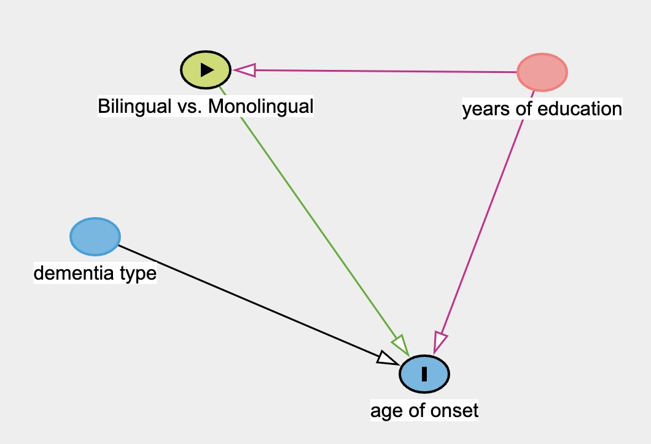
Figure 1: Directed Acyclic Graph showing the potential influence of years of education (confounding variable) and dementia type (modulating variable).
Additionally, immigration status has been argued to confound the bilingualism effect since healthier people are more likely to become immigrants, who are also bilingual (Fuller-Thomson & Kuh, 2014). However, this meta-analysis will not further analyse the effect of immigration status because of the following reasons. Firstly, many studies demonstrating a bilingualism effect have shown that the influence of immigration status is limited since their participants were non-immigrants (e.g., Alladi et al., 2013; Zheng et al., 2018). In other words, if the bilingualism’s protective effect on dementia is indeed due to the healthy immigrant effect, no bilingualism advantage is supposed to be found in these studies. Secondly, Brini et al. (2020) conducted subgroup analyses to compare the study that adjusted for immigration status to those that did not in their meta-analysis of bilingualism and age at onset of dementia. The results showed that the two subgroups were not significantly different concerning bilingualism’s delaying effect (Brini et al., 2020). Thus, the present meta-analysis will not repeat the subgroup analysis of immigration status.

Dementia Type as a Modulating Variable
As mentioned in the introduction, bilingualism’s effect may be different for different types of dementia (Alladi et al., 2013). Even within the same sample, the difference in the delaying effect can be quite large (4 years for FTD dementia and 1.4 years for Mixed dementia in Alladi et al., 2013). On the contrary, different types of dementia do not affect the bilingual status of individuals. Therefore, the types of dementia only modulate the strength of bilingualism effect on delaying the age at onset. Additionally, this meta-analysis also includes MCI studies, which are not traditionally dementia studies. It would be necessary to run subgroup analyses to better summarise its potential effect and to demonstrate whether the type of dementia is a source of inconclusive results. The model for subgroup analysis is similar to the main Bayesian meta-analysis model, with the data restricted to the relevant subgroup.

Results

Literature Searching
Shown in Figure 2, a total of 24 studies were included through searching the databases and checking the references of previous meta-analyses. Among the 24 studies, 18 studies’ primary outcome measures were age at onset/diagnosis of dementia or MCI (k = 18), and the rest of them were the risk of developing dementia (k = 6).
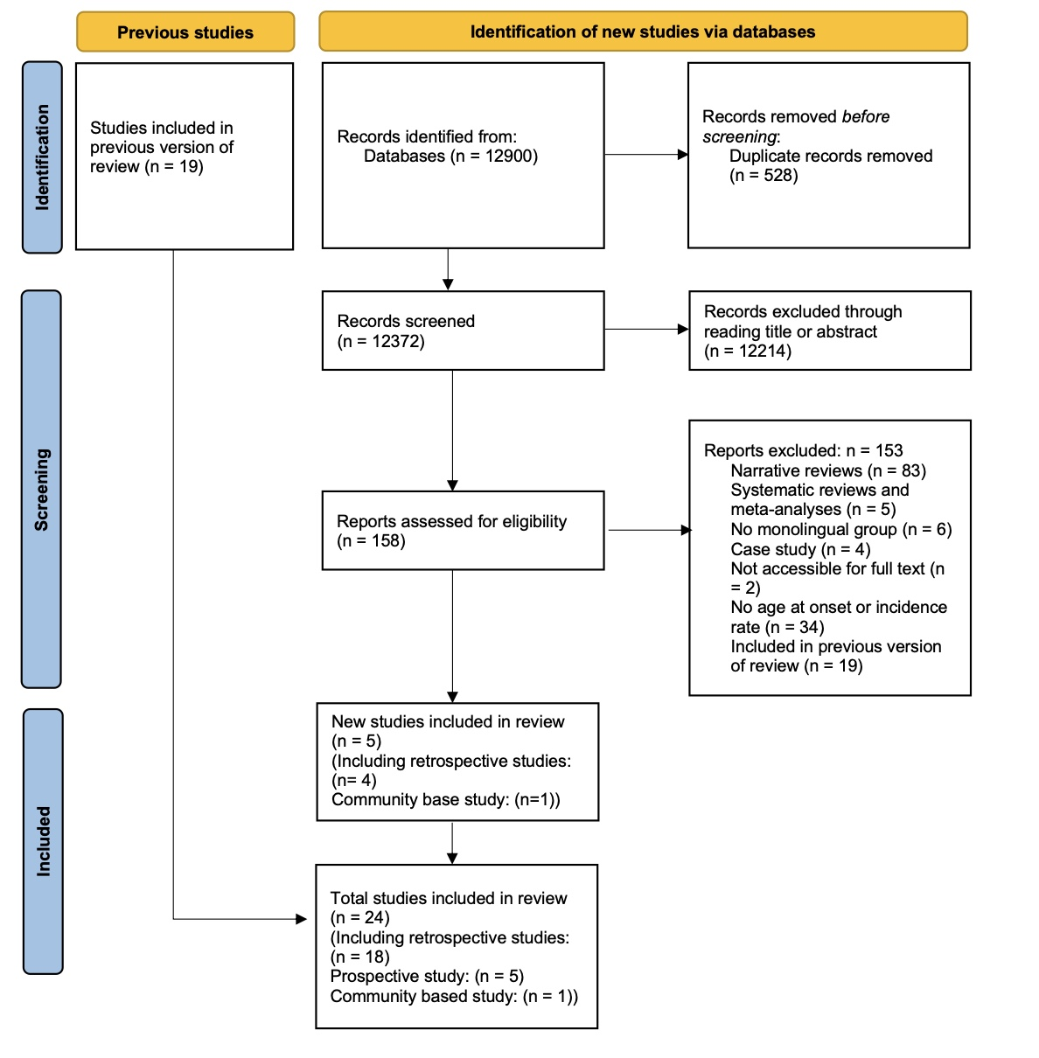
Figure 2: Prisma flow diagram showing the number of studies included in the meta-analysis according to PRISMA (Preferred Reporting Items for Systematic reviews and Meta-Analysis) 2020.
To fit in the Bayesian meta-analysis model, we retrieved the summary data from each study, including the age at onset/diagnosis, standard deviation, number of individuals in bilingual and monolingual groups, years of education for each group, and dementia types in each study. One special case is that Zheng et al. (2018) included two monolingual groups: Mandarin and Cantonese. Different from previous meta-analyses that combine them into one monolingual group (Brini et al., 2020), the Bayesian linear model allows for two monolingual groups and one bilingual group. For the age at onset/diagnosis model, the final included sample was 23 pairs of participants (N = 3674, including 2023 monolinguals and 1641 bilinguals).

Prior Distribution Setting
For a specified Bayesian model, the posterior inference relies on both the likelihood and the prior (Schmid et al., 2020). The present Bayesian random-effect model for age at onset studies specifies three priors. First, it specifies an LKJ (2) prior on the correlation matrix (Nicenboim et al., 2024). The setting of its parameter 𝜂 = 2 would avoid favouring extreme correlations, which provides a relatively uninformative or weakly informative prior. Second, it specifies a Student-t distribution with 3 degrees of freedom, mean of 0 and scale of 9 since it is the brms default. This prior expects the standard deviations of the random effects to have large variability since different studies included in the meta-analysis may have large heterogeneity. Third, the prior for the main coefficients is a Gaussian distribution with mean = 65 and SD = 25. This indicates that values (in this case, age at onset of dementia) would fall within 95% CrI of (65 ± 2*22.5) years. The reason for a prior belief of the mean age at onset to be centred around 65 is that most previous studies have dementia age at onsets around 58 and 76, which is important historical evidence (Turner et al., 2009). Also, the 95 credible intervals of 20 and 110 provide enough variability for the age onset of adult neurodegenerative disease.

Results for Meta-analysis of Bilingualism and Age at Onset of Dementia
We fitted a Bayesian linear regression model with language group (bilingual vs. monolingual) as the predictor, mean (age at onset) as the outcome variable and measurement error (added with se (SE) at the left side of the model formula). All models converged with acceptable R-hat and acceptable sample size values. The FTD subgroup model and MCI subgroup model finished with 36 and 16 divergent transitions respectively, which we did not deem problematic given the R-hat and effective sample size values.
The results showed that at the population level, the estimated age at dementia onset for monolinguals was between 65.04 and 71.55 years at 95% CrI ($β$ = 68.39, Est.Error = 1.64). For bilinguals, the estimated age at dementia onset was between 68.82 and 74.61 years at 95% CrI ($β$ = 71.68, Est.Error = 1.49). Comparing the posterior draws directly, the posterior probability that bilinguals had a later dementia onset than monolinguals was 1. We further used the avg_comparisons() function to summarise the average marginal effects for bilinguals and monolinguals (Arel-Bundock et al., 2024), which showed that the average marginal effect between the age at dementia onset for bilinguals and monolinguals was between 2.8 and 4.1 years at 95% CrI with an estimate of 3.45 years. This suggests that the bilingual population tends to have a later dementia symptom onset of around 3.45 years than monolinguals. A similar trend was also shown in the forest plot of the study-specific difference in effect for bilinguals and monolinguals, in which the majority of the studies have a positive value that favours bilingualism (see Figure 3). The majority of studies’ 95% credible interval was positive. Only one study (Duncan et al., 2018) resulted in a negative effect that monolinguals have a later dementia onset than bilinguals by around 1.42 years. It is important to note that the credible interval of the predicted average estimate (from avg_comparisons()) is narrower than those observed in the study-specific estimates in the forest plot. This is because the calculated interval is based on the mean predicted effect of each observation in the dataset, for each MCMC draw.
Overall, the meta-analytic effect showed a positive effect, indicating that bilingualism is associated with a delayed onset of dementia. The following section explores the heterogeneity across the studies.
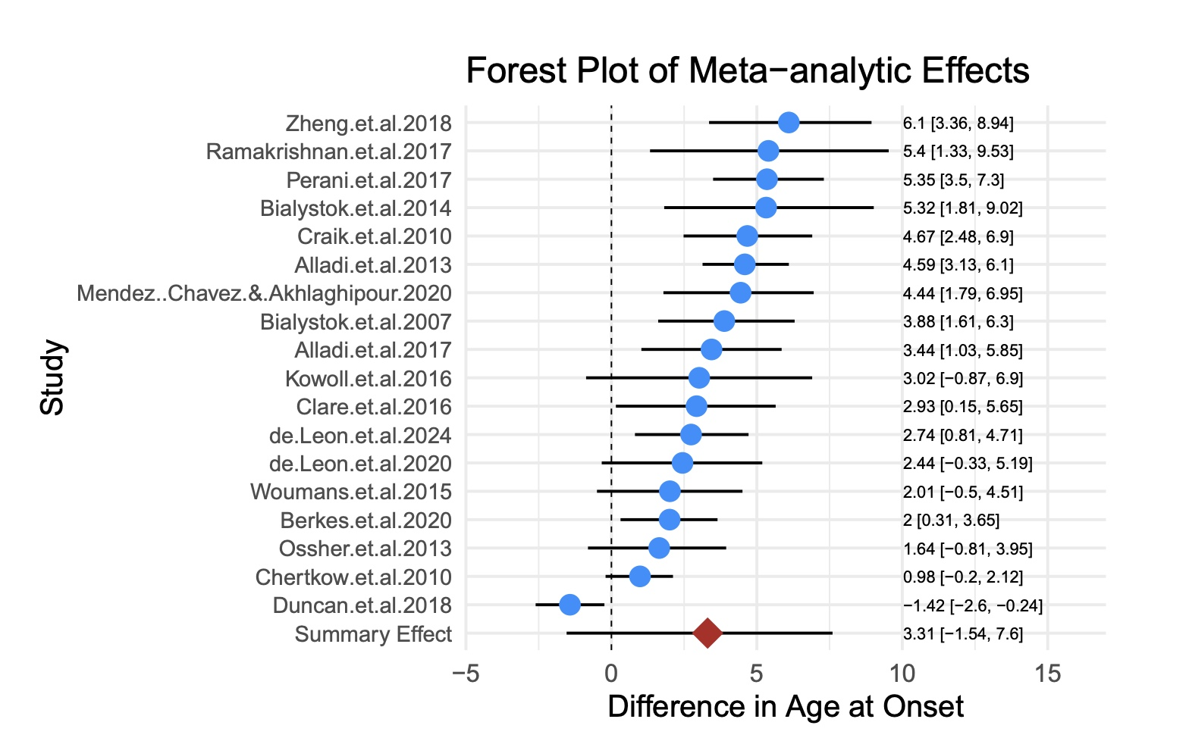
Figure 3: Forest plot of Bilingualism and Age at Onset of Dementia (Note: The estimates and 95% CrI are the differences between bilinguals and monolinguals, so a positive number indicates later onsets for bilinguals.)

Heterogeneity across Studies
In the present Bayesian meta-analysis model, heterogeneity was mainly expressed by the random effects at the group level, which was the difference in age at onset for monolingual group and bilingual group across different study levels. At the group level, the standard deviation for monolingual group and bilingual group was 7.13 with a 95% CrI [5.24, 9.93], and 6.54 with a 95% CrI [4.79, 9.15]. This relatively large standard deviation indicated that there was high heterogeneity across studies, although the summary meta-analytic effect was positive. This indicated that the summary effect may be influenced by the large heterogeneity and that it would be necessary to examine the source of such heterogeneity. Therefore, we used the spread_draws() function (Kay & Mastny, 2023) to draw two new forest plots that show the difference between the population-level mean age at dementia onset and each study’s age at dementia onset for bilinguals and monolinguals, respectively (see Figure 4).
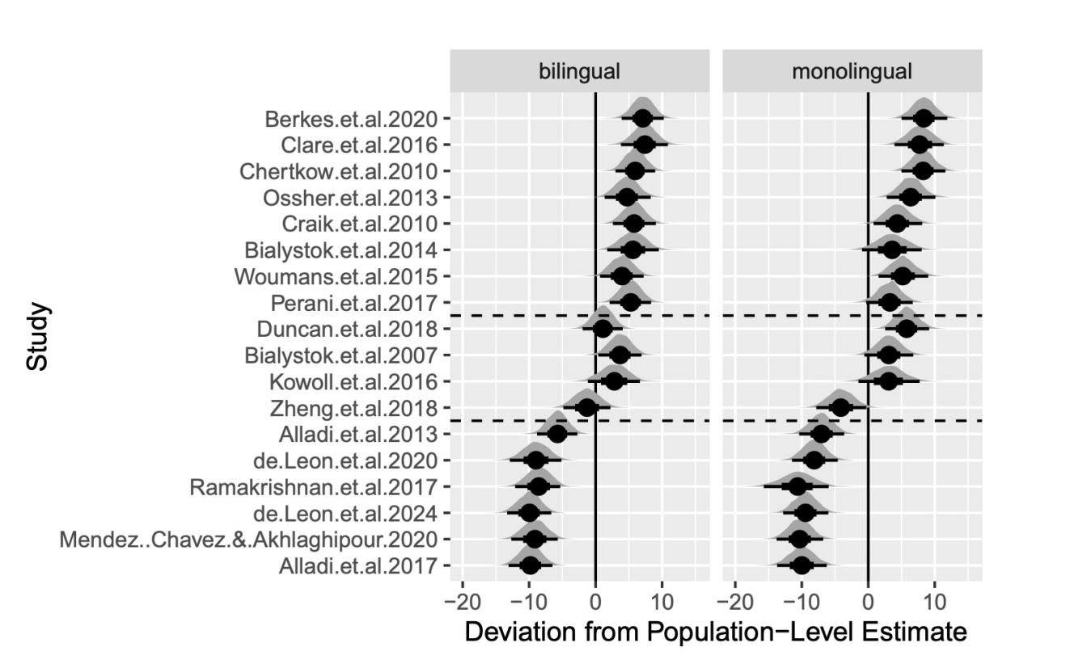
Figure 4: Forest plot showing the estimated difference between each study’s estimate and population-level estimate grouped by bilingual and monolingual group (the dashed line marks the approximate boundaries between the three groups).
As illustrated in Figure 4, the studies seemed to be divided into three groups for each of the two plots. The estimated mean age at onset for the first group of 8 studies was later than the population-level age at onset for around 3 to 8 years (Berkes et al., 2020; Bialystok et al., 2014; Chertkow et al., 2010; Clare et al., 2016; Craik et al., 2010; Ossher et al., 2013; Perani et al., 2017; E. V. Y. Woumans et al., 2015). For the second group of 6 studies, the mean age at onsets were earlier than the population-level age at onset for around 6 to 10 years (Alladi et al. (2013); Alladi et al. (2017); Leon et al. (2020); Leon et al. (2024); Ramakrishnan et al. (2017); Mendez et al. (2020)). The third group of 4 studies (in the middle of the plot) were more complex, which clustered around the estimated population-level age at onset, yet with different patterns for bilinguals and monolinguals (Bialystok et al., 2007; Duncan et al., 2018; Kowoll et al., 2016; Zheng et al., 2018). For instance, in Duncan et al. (2018), the estimated mean effect for the bilingual group was close to the population-level effect, but the monolinguals’ estimation was more than 5 years later than the population-level effect for monolinguals. Such a difference in monolingual and bilingual groups made Duncan et al. (2018) the only study that had a bilingual early mean dementia onset estimation, as shown in Figure 3.
A careful investigation into the contexts of each study provided some potential evidence for such heterogeneity. One prominent difference between the first and second groups of studies might be the type of dementia. Among the 6 studies in the second group, three of them involved the FTD variant of dementia, one of them involved MCI patients and the other two involved AD patients. In contrast, seven out of eight studies in the first group and all of the four studies in the third group involved AD patients despite one study having MCI patients. Such differences in the distribution of types of dementia among different groups of studies further called for subgroup analyses of different types of dementia and to investigate whether the type of dementia influences the differences in age at onset of dementia in bilinguals and monolinguals.

The Role of Education is Uncertain
To examine whether years of education had an influence on the meta-analytic effect, we included years of education into the right side of the previous Bayesian linear model. The results showed that the population-level effect of “years of education” on the age at onset of dementia was between -0.63 and 0.36 at 95% CrI ($β$ = -0.11, Est.Error = 0.26). It was quite uncertain about the role of Education since the effect involves both negative and positive values. This indicates that we are still uncertain whether “years of education” has an effect on age at onset of dementia (either positive or negative) or not, based on the data in the meta-analysis.
Additionally, the estimated mean age at dementia onset for monolinguals and bilinguals was 69.62 years with a 95% CrI [63.16, 77.00] and 73.03 years with a 95% CrI [66.05, 80.53] after including years of education into the model. The results from comparing posterior draws showed that the probability of bilinguals having delayed dementia onset was still 100%. Using avg_comparisons() again, the mean average difference between the age at dementia onset for bilinguals and monolinguals was 3.65 years with a 95% CrI [2.55, 4.91]. The result was close to the previous model, where education was not included (3.45 years with a 95% CrI [2.8, 4.1]). Therefore, the results from Bayesian linear regression indicated that years of education did not have a strong effect on the effect of bilingualism on age at onset of dementia, although the role of education is uncertain.

Subgroup Analyses of Dementia Type
Cross-sectional Studies of Three Dementia Subgroups
Study | Dementia Diagnosis | Type of Dementia or MCI | Mean Age of Diagnosis & Symptom Onset (SD)
Alladi et al. (2013) | Cambridge Memory Clinic model | AD | ML: 65.4 (10.0); BL: 68.6 (9.6)
Bialystok et al. (2007) | NINCDS-ADRDA | AD | ML: 71.4 (9.6); BL: 75.5 (8.5)
Bialystok et al. (2014) | NA | AD | ML: 70.9 (11.0); BL: 78.2 (8.9)
Berkes et al. (2020) | MMSE, MoCA | AD | ML: 78.2 (7.7); BL: 79.8 (8.4)
Chertkow et al. (2010) | Patient & caregiver interviews | AD | ML: 76.7 (7.8); BL: 77.6 (7.2)
Clare et al. (2016) | LQ-SV | AD | ML: 76.2 (8.75); BL: 79.3 (6.78)
Craik et al. (2010) | NA | AD | ML: 72.6 (10); BL: 77.7 (7.9)
Leon et al. (2020) | NA | AD | ML: 60.3 (9.8); BL: 61.9 (9.8)
Duncan et al. (2018) | NINCDS-ADRDA | AD | ML: 74.3 (1.5); BL: 72.6 (1.6)
Kowoll et al. (2016) | NINCDS-ADRDA | AD | ML: 71.6 (7.9); BL: 74.6 (6.8)
Perani et al. (2017) | NIA-AA | AD | ML: 71.4 (4.88); BL: 77.1 (4.52)
Mendez et al. (2020) | NIA-AA | AD | ML: 58 (10.7); BL: 62.4 (10.5)
E. V. Y. Woumans et al. (2015) | Neurologist + Neuropsychologist | AD | ML: 73.8 (8.8); BL: 75.5 (8.2)
Zheng et al. (2018) | NINCDS-ADRDA | AD | ML: 63.9 (96.5), 63.4 (8.94); BL: 70.9 (9.37)
Alladi et al. (2013) | Cambridge Memory Clinic model | FTD | ML: 55.6 (10.5); BL: 61.6 (9)
Alladi et al. (2017) | MMSE, ACE-R, CDR, FrSBe | FTD | ML: 58.4 (9.3); BL: 61.7 (9.1)
Leon et al. (2024) | NA | FTD | ML: 59 (9.2); BL: 61.4 (7.9)
Berkes et al. (2020) | MMSE, MoCA | MCI | ML: 75.5 (7.6); BL: 77.8 (8.2)
Ossher et al. (2013) | Neuropsychological interview | Single Domain aMCI | ML: 74.9 (49); BL: 79.4 (6.3)
Ossher et al. (2013) | Neuropsychological interview | Multiple Domain aMCI | ML: 75.2 (8.5); BL: 72.6 (7.2)
Ramakrishnan et al. (2017) | Petersen’s criteria | MCI | ML: 55.8 (12.2); BL: 63.2 (10.1)
Abbreviations: ML = Monolinguals; BL = Bilinguals; AD = Alzheimer’s Disease, FTD = Frontotemporal Dementia, MCI = Mild Cognitive Impairment; aMCI = Amnestic Mild Cognitive Impairment
ACE-R = Addenbrooke’s Cognitive Examination-revised; FrSBe = Frontal Systems Behaviour Scale;
LQ-SV = Language Questionnaire - Short Version;
MMSE = Mini-Mental State Examination; MoCA = Montreal Cognitive Assessment;
NINCDS-ADRDA = National Institute on Aging-Alzheimer’s Association consensus criteria
The subgroup analyses was used to compare whether the difference of the age at onset of dementia between bilinguals and monolinguals was different across different types of dementia. The studies were divided into three subgroups: AD dementia subgroup (including 14 studies), FTD subgroup (including 3 studies), and MCI subgroup (including 3 studies), which are listed in the above table. The total number of studies was 20 because two studies (Alladi et al., 2013; Berkes et al., 2020) involved more than one type of dementia. For each subgroup, a Bayesian linear regression model which is similar to the main meta-analysis was employed with the same priors that had been set before.
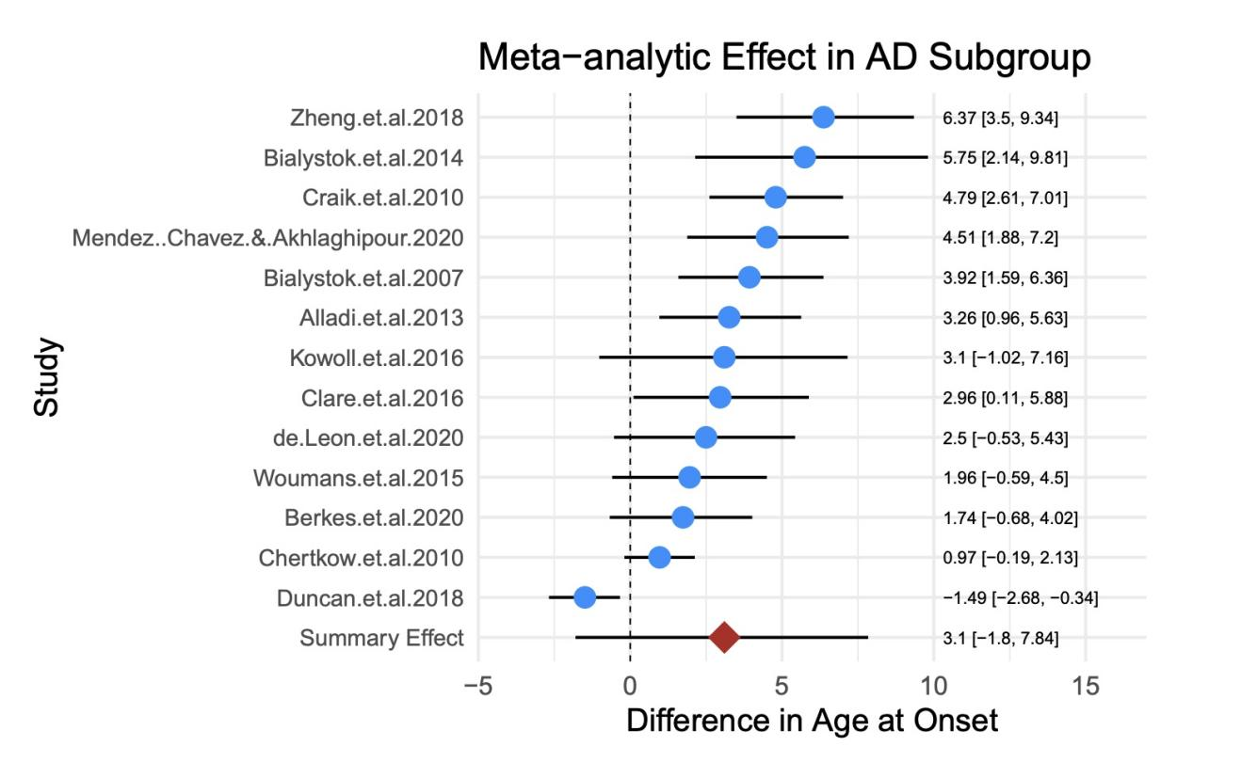
Figure 5: AD Subgroup: Forest plot of Bilingualism and Age at Onset of Dementia
Note. AD = Alzheimer’s Disease
For the AD dementia subgroup (see Figure 5 for the forest plot), the results showed that at the population-level, monolinguals had an age at AD onset of 70.39 years with a 95% CrI [66.90, 73.33] while the age at AD onset for bilinguals was 73.68 with a 95% CrI [70.59, 76.69]. Comparing the posterior draws directly, the posterior probability that bilinguals had a later dementia onset than monolinguals was 98.8%. The mean average difference between the age at AD onset for bilinguals and monolinguals was 3.36 with a 95% CrI [2.61, 4.15]. Compared with the main meta-analytic results, the estimated age at AD onset was higher for both monolingual and bilingual populations. Yet, the difference between bilinguals’ and monolinguals’ age at onset (3.36 years) was smaller although very close to the main effect (3.45 years). Moreover, the level of heterogeneity decreased moderately compared with the mean meta-analytic results since the group-level estimated effects for monolingual group and bilingual group were 6.09 and 5.57, respectively.
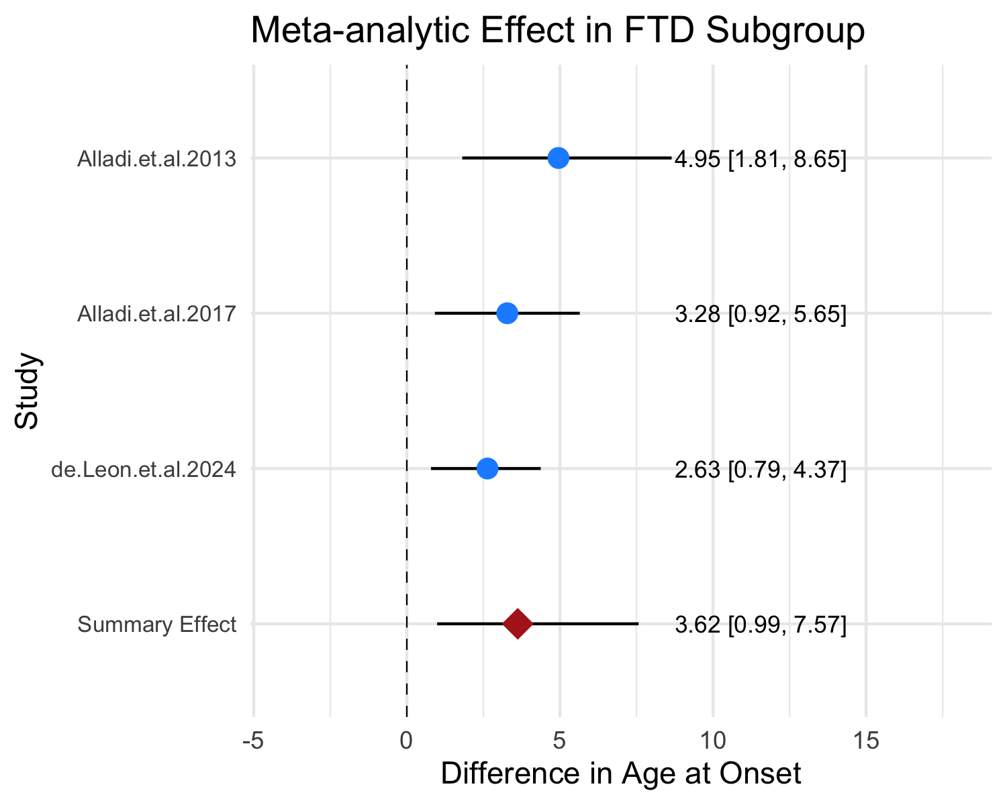
Figure 6: FTD Subgroup: Forest plot of Bilingualism and Age at Onset of Dementia
Note. FTD = Frontotemporal Dementia
For the FTD dementia subgroup (see Figure 6 for the forest plot), the estimated age at FTD onsets for monolinguals and bilinguals were 57.96 with a 95% CrI [53.16, 62.10] and 61.52 with a 95% CrI [59.05, 63.73], which were largely lower than the main meta-analytic effect and the AD subgroup’s onset. The comparison of the posterior draws showed that the probability that bilinguals had a later dementia onset than monolinguals was 94.5%. Using avg_comparisons() again, the average difference in marginal effects for bilinguals and monolinguals was 3.63 with a 95% CrI [1.92, 5.26]. This showed that bilinguals are estimated to be 3.63 years older than monolinguals on average when having the first symptom onset for FTD type of dementia. The heterogeneity level was even lower in this group as since the group-level estimated effects for monolingual group and bilingual group were 2.85 and 1.39. Yet, the relatively low number of studies might have contributed to the low heterogeneity and the wide 95% CrI of the estimated difference between bilinguals and monolinguals at the population level.
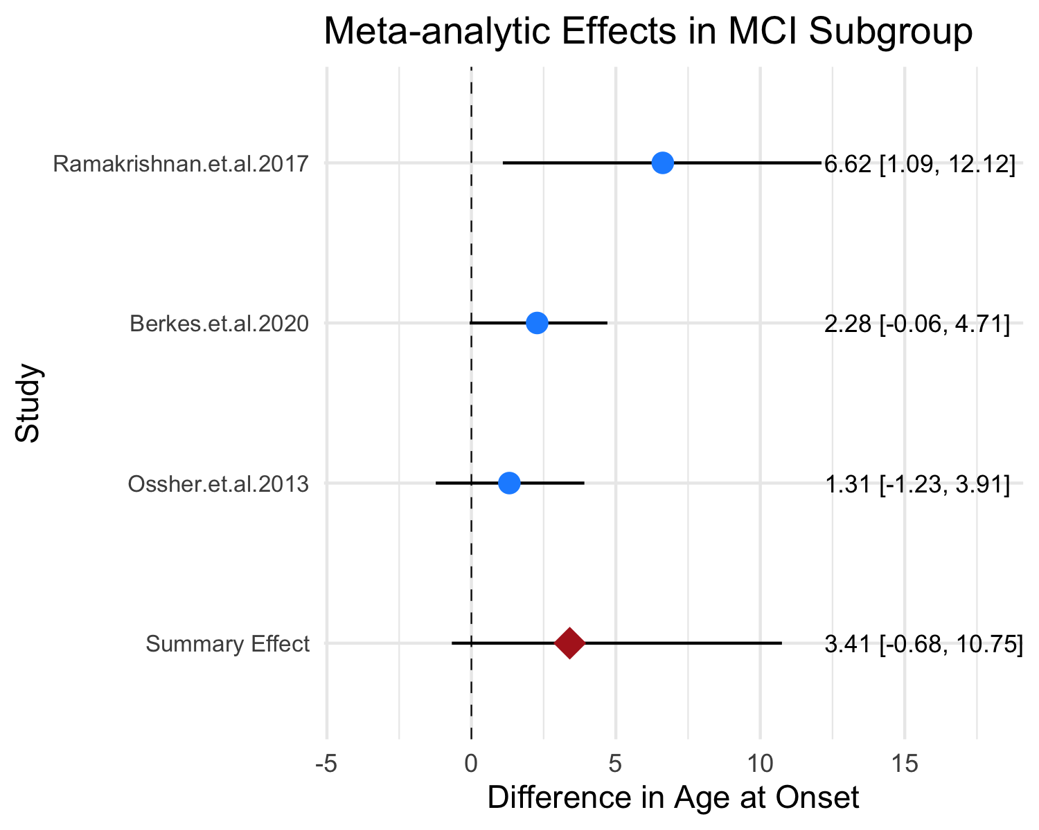
Figure 7: MCI Subgroup: Forest plot of Bilingualism and Age at Onset of Dementia
Note. MCI = Mild Cognitive Impairment
For the MCI subgroup (see Figure 7 for the forest plot), the estimated age at MCI onsets was 68.52 (95% CrI [54.91, 80.60]) for monolinguals and 72.06 (95% CrI [59.80, 83.31]) for bilinguals, which was slightly earlier than AD subgroup. Such results were expected since mild cognitive development is the transitional stage between healthy brain condition and dementia (Frank & Petersen, 2008). However, comparing the posterior draws, 73% of the posterior samples favoured a bilingual delayed onset for MCI. The probability is lower than AD (99.8%) and FTD (94.5%). The average difference in marginal effects estimated through avg_comparisons() for bilinguals and monolinguals was 2.88 years with a 95% CrI [0.914, 4.84]. This difference between the age at onset of bilinguals and monolinguals was the smallest in the three subgroups. Additionally, the standard deviation for monolingual (11.50) and bilingual (9.19) (group-level effects) were the largest among the three groups. This indicated that there were large variations between the age at onset across different studies in the MCI subgroups. It could be because one study’s (Ramakrishnan et al., 2017) age at MCI onset was extremely lower than the other two (Berkes et al., 2020; Ossher et al., 2013).
Comparing the three subgroups at the population-level, it could be found that the AD subgroup had the latest age at onset for both bilinguals and monolinguals while the FTD subgroup had the earliest. For the difference between the age at onset of bilinguals and monolinguals, the FTD subgroup had the largest difference following the AD subgroup. The MCI subgroup’s difference was quite smaller than the two. Additionally, the difference in heterogeneity among the groups may account for the relatively large heterogeneity in the main meta-analysis. These results will be further discussed in the discussion section.

Addressing Bias
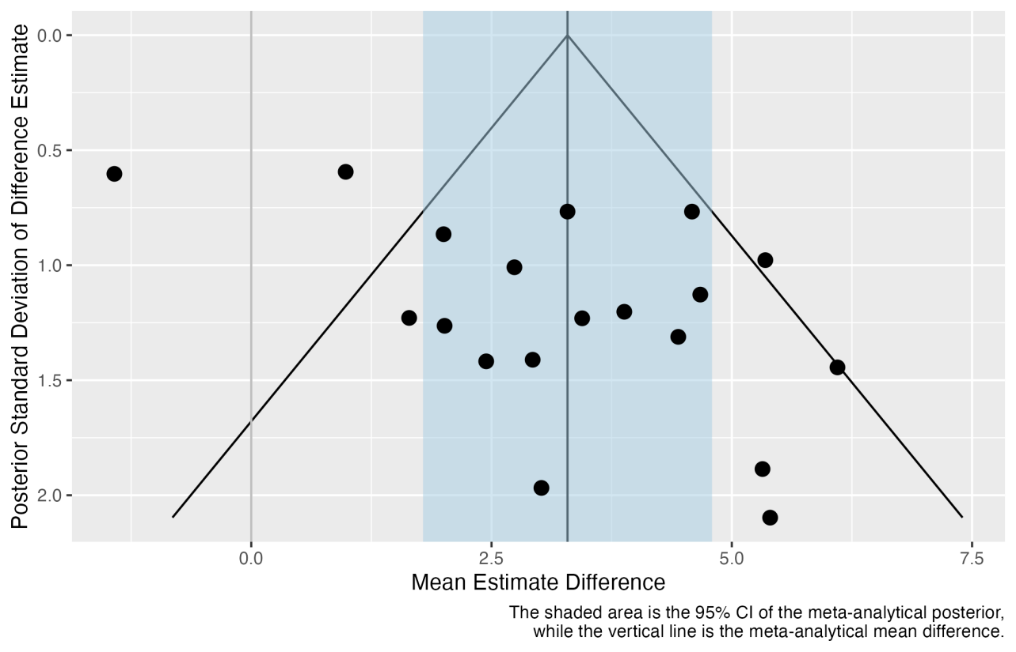
Figure 8: Funnel plot showing standard deviation differences between bilinguals and monolinguals in age at onset of dementia.
Potential bias in the meta-analytic estimates was assessed using the funnel plot method (Light & Pillemer, 1984). The funnel plot Figure 8 shows the mean estimated difference of age at onset for each study on the x-axis and their estimated error on the y-axis. The shaded light blue area is the 95% CI of the meta-analytic effect of the mean estimated difference of age at onset. The vertical line is the summary meta-analytic effect. As shown in the plot (Figure 8), the dots are not symmetrically distributed around the summary effect although the number of studies on the left side of the summary effect is the same as the number on the right side. Moreover, two studies on the left (Chertkow et al., 2010; Duncan et al., 2018) and one study on the right (Perani et al., 2017) were not covered in the funnel shape. This means that there is potential bias caused by the selected studies. Therefore, it was necessary to check whether the meta-analytic effect was greatly influenced by potential bias.
We removed the studies that fell outside the funnel shape to rerun the Bayesian linear model. At the population level, the results showed that the estimated age at dementia onset for monolinguals is 66.46 with a 95% CrI [62.75, 70.17] and for bilinguals is 70.37 with a 95% CrI [67.03, 73.81]. The estimated average difference in the onset of dementia between bilinguals and monolinguals is 3.88 years with a 95% CrI [3.11, 4.65], which is even higher than the mean meta-analytic effect, 3.45 years. This provides evidence that the meta-analytic effect was not a total result of bias.

Results for Meta-analysis of Bilingualism and Dementia Prevalence Studies
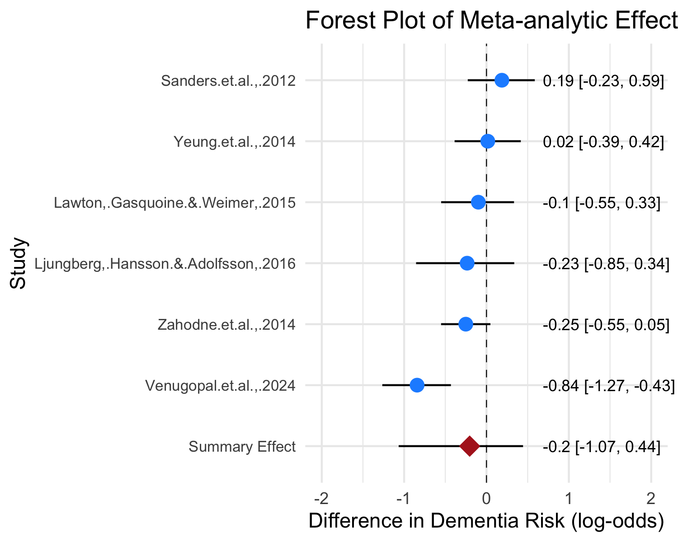
Figure 9: Forest plot of the estimated difference in dementia risk between bilinguals and monolinguals in each study.
To investigate whether bilingualism is associated with reduced dementia risks, we fitted a Bayesian hierarchical logistic regression model predicting the number of dementia cases out of total number of participants using a binomial likelihood. All models converged with acceptable R-hat and acceptable sample size values. The results showed that the population-level estimate for monolingual is -2.06 with a 95% CrI [-3.05, -1.16] and that the estimate for bilingual is -2.27 with a 95% CrI [-3.09, -1.47]. The results from the comparison of posterior distribution for the log-odds of bilinguals and monolinguals showed that 77% of the posterior samples indicated lower odds of dementia for bilinguals. We also used avg_comparisons() to show the ratio of the average predicted probability of dementia for bilinguals to the average predicted probability of dementia for monolinguals, which resulted in a 0.844 estimate with a 95% CrI [0.725, 0.984]. For the ratio, a result between 0 and 1 indicates lower incidence rate of bilinguals while a result over 1 indicates higher incidence rate of bilinguals. This indicated that the average predicted probability of dementia for bilingual individuals was from 72.6% to 98.4% of the average predicted probability of dementia for monolinguals. In other words, the meta-analytic effect was likely to fall between 1.6% and 27.4% lower incidence for bilinguals compared with monolinguals based on the included 6 studies. This is a small to moderate effect for bilingualism (see Figure 9 for forest plot). It is possible that such a result was influenced by bias, given the relatively small number of studies. Yet, the funnel plot is believed not to be reliable if the number of studies is under 10 (Sedgwick & Marston, 2015). Therefore, the present meta-analysis did not use the funnel plot to address the potential bias.
Nevertheless, a detailed inspection of the context of these studies and the forest plot (Figure 9) revealed that one study had great influence on the results (Venugopal et al., 2024). The estimated difference in dementia risk of bilinguals and monolinguals is between -1.27 and -0.43 log-odds at 95% probability, which corresponds to 21.9% and 39.4% lower probability for bilinguals (Venugopal et al., 2024). The study design of this community-based study is a cross-sectional study, which is different from the other five longitudinal studies. Considering such a difference, we reran the Bayesian model without Venugopal et al. (2024). Comparing the posterior distribution of this model, the results showed that the probability that bilinguals had lower incidence rate than monolinguals was only 64%. The results of avg_comparisons() showed that the average incidence rate for bilinguals is about 86.6% of the incidence rate of monolinguals with a 95% CrI [0.634, 1.5]. This means that we are relatively uncertain about whether bilinguals have a lower incidence rate than monolinguals at the population-level, since the 95% credible interval spans a wide range of values both below and above 1, which indicates considerable uncertainty.

Discussion
Numerous studies have investigated whether bilingualism influences aging and neurodegenerative disease, without reaching a conclusive remark. Recently, three meta-analyses examined bilingualism and age at dementia onset or bilingualism and dementia prevalence rate (Anderson et al., 2020; Brini et al., 2020; Mukadam et al., 2017). However, the present study is the first meta-analysis to use Bayesian statistics to explore bilingualism and dementia. Moreover, it addressed the following research questions: Does bilingualism have protective effects on delaying the onset of dementia? Is there a preventing effect of bilingualism on dementia? Do education as a confounding variable and dementia type as a modulating variable influence the relation between bilingualism and the age at onset of dementia?

Bilinguals Have a Delayed Onset of Dementia
In terms of the first research question (i.e., Are there differences between the age at onset of dementia for bilinguals and monolinguals? If so, is the effect influenced greatly by bias?), the findings reveal that bilinguals are 3.45 years older than monolinguals on average when they first have symptoms of dementia. This is in line with the results of two previous meta-analyses which found a moderate protective effect of bilingualism on age at dementia onset ranging from effect size Cohen’s d = 0.32 (Anderson et al., 2020) to a delay of 4.7 years for AD symptoms onset (Brini et al., 2020). A further inspection of potential bias using funnel plot reveals the existence of bias since three studies lie outside the funnel shape. Yet, the difference between bilingual and monolingual populations’ age at dementia onset was even larger (3.65 years on average) after removing the three studies in the model. Therefore, the present meta-analysis provides evidence for a potential bilingualism effect on delaying the onset of dementia, which supports the bilingualism and cognitive reserve link that was discussed in section 2.2.

The Bilingualism’s Preventive Effect is not Robust
For the second research question (i.e., Is there a bilingualism’s preventing effect on dementia?), the present meta-analysis did not produce robust evidence although the meta-analytic effect favours bilingualism. The meta-analytic effect is that the incidence rate of dementia for bilinguals is 1.6% to 27.4% lower than that of monolinguals at 95% probability with an average estimate of 15.5% lower incidence. This result is largely in line with (Anderson et al., 2020), which found weak evidence for bilingualism preventing dementia (Cohen’s d = 0.10).
However, the results in this analysis were greatly influenced by one individual study, Venugopal et al. (2024), which had a large effect. Venugopal et al. (2024) is a community-based study with 1234 participants from Bengaluru, India. Instead of following the participants for years to collect the incidence rate in a period, they simply counted the number of participants, who developed dementia at the time when the study was conducted. Their results showed that 46 out of 803 bilinguals and 58 out of 431 monolinguals had dementia or MCI. Yet, such results may not be robust to support bilingualism’s effect on preventing the disease. One explanation could be that bilinguals have a delayed onset of dementia; some bilinguals in Venugopal et al. (2024) sample would develop dementia in the end yet did not show symptoms when they were researched. In this sense, bilinguals only delay the dementia onset rather than totally prevent the disease (Berkes & Bialystok, 2022). The results became more uncertain after removing Venugopal et al. (2024), providing no robust evidence for bilingualism’s preventive effect on dementia. This result (incidence rate: bilinguals/monolinguals 95% CrI [0.634, 1.5]) corresponds to Mukadam et al. (2017), which found an odds-ratio of [0.74, 1.23] at 95% confidence. Therefore, the present meta-analysis did not find robust evidence for bilingualism’s preventive effect on dementia.

Confounding and Modulating Variables

No Evidence for Education to be a Confounding Variable or not
This Bayesian meta-analysis also examined whether education confounded the bilingualism effect on delaying the onset of dementia. The results from the Bayesian linear regression model reveal that it is uncertain whether the year of education is a predictor of age at onset for dementia or not. Yet, bilingualism’s effect on dementia is not influenced by years of education based on the results. Such results are largely in accordance with previous studies which showed that bilingualism’s effect on delaying the onset of dementia was independent of education and other socioeconomic factors (e.g., Alladi et al., 2013; Anderson et al., 2020; Craik et al., 2010). Therefore, the present analysis further shows that differences in the bilinguals’ and monolinguals’ education status are not predictive of their differences in the age at symptom onset of dementia.

Bilingualism may Defer Different Types of Dementia Differently, though Uncertainity Remains
Many recent studies have pointed out that bilinguals’ delay in age at dementia onset may be specific to different subtypes of dementia (Alladi et al., 2013; Lee, 2022). The results from the in this meta-analysis provide evidence for such arguments. The difference between bilinguals and monolinguals was the largest on FTD subtype (3.63 years on average) following the AD subtype (3.36 years on average) and MCI (2.88 years on average). While the mean estimates of the three groups suggest possible variation in bilingualism’s effect across dementia types and MCI, the 95% credible intervals for the subgroups overlap, and the number of studies available for each subtype is limited. Therefore, uncertainty remains regarding whether these differences reflect true variation across dementia types.
One explanation for the potential differences may be that the brain regions that are affected by different subtypes of dementia vary (Lee, 2022). For instance, AD subtype mainly affects the neurons in the entorhinal cortex and hippocampus (Meda et al., 2013); FTD subtype causes atrophy in the frontal and temporal lobes (Chan et al., 2001) while vascular dementia subtype involves damage of white matter beneath the grey matter (Hase et al., 2018). Therefore, it could be that bilingualism tends to affect the functional connectivity of frontal and temporal lobes more efficiently as mentioned in section 2.2. Moreover, different language use experiences may affect distinct brain areas, which indicates that bilinguals with different language experience may show different “advantages” in resisting various kinds of brain pathologies (Lee, 2022). Unfortunately, few studies have reported the language experience of bilinguals in detail. Therefore, it would be helpful to narrow down bilingualism to different types of bilingual activity such as frequent vs. infrequent switching between languages, production practice dominant vs. perception practice dominant bilingualism.
Future empirical studies investigating the bilingualism and dementia link are suggested to view bilingualism and dementia as highly dynamic phenomena rather than unitary ones. More efforts should be made to investigate the neuropathology of different subtypes of dementia and how different bilingualism experiences affect the onset of symptoms of these subtypes.

The Uniqueness of Bilingualism among Cognitive Reserve Factors
At the end of the discussion, we should point out that bilingualism is not the only factor that contributes to cognitive reserve and the delay of dementia. Yet, bilingualism occupies a unique role compared with other mentally challenging activities such as engaging in difficult physical activities (Sofi et al., 2011), playing an instrument (Hanna-Pladdy & MacKay, 2011). From the neurological mechanism perspective, bilingualism stands out for its ubiquitousness across the lifespan, independent of contextual need or consciousness. It contributes to neuroplastic change in multiple brain regions that are strongly implicated in brain aging. The overlap between the bilingual language control network and the frontoparietal network for domain-general control helps bilingual to constantly maintain higher functional and neurostructural integrity during aging (Gallo & Abutalebi, 2024; Wu et al., 2019). From the social dimension, bilingualism is arguably more accessible and equitable than other cognitive reserve factors since the motivation and attitudes towards higher level of education, muscianship, and exercise are heavily influenced by socioeconomic status (Gallo & Abutalebi, 2024; Wardle & Steptoe, 2003). The present meta-analysis on bilingualism and dementia add to a growing body of evidence coining its distinctive role in cognitive reserve and delaying dementia onset, which provides significant implications for individuals, caregivers, and public health systems.

Limitations
One potential limitation of the present meta-analysis is that it does not view bilingualism as a continuum. This is partially because most previous empirical studies employed a dichotomous categorization of bilinguals and monolinguals. For the studies that did use bilingualism as a continuum, measurements also vary since some used the frequency of code-switching (Calabria et al., 2020) while others used objective measures (e.g., Boston Naming Test in Gollan et al., 2012). Given the limited number of such studies and various measurements, the present meta-analysis did not include them. Future meta-analyses can attempt to include these studies as more new studies using similar measurements appear.
Borenstein et al. (2021) states that it is rare for researchers to collect all the studies that meet the inclusion criteria into the meta-analysis. We are aware that some studies that meet the inclusion criterion might be missing and that access to unpublished articles was limited. The relatively small number of studies (18 studies for age at onset and 6 studies for incidence rate) might be the reason for notable uncertainty in the results of the Bayesian linear regression model.

Conclusion
This meta-analysis investigated the correlates of bilingualism and the age at onset and incidence rate of dementia respectively. The results of the age at onset part provided evidence for the potential bilingualism effect on delaying the onset of dementia that bilinguals are 3.45 years later than monolinguals when the symptoms appear. Moreover, it revealed that education does not strongly influence the link between bilingualism and dementia. The subgroup analyses provided evidence that the types of dementia may influence the relation between bilingualism and the age at onset of dementia. Yet, the uncertainty reflected in overlapping posterior distributions across groups and the limited number of studies calls for more research into different subtypes of dementia. In contrast, the results of the incidence rates study did not support that bilingualism prevents dementia from happening. Yet, we did not reach Mukadam et al. (2017) conclusion that bilingualism has no effect on protecting against cognitive decline. Instead, the results support that bilingualism has potential protective effects on delaying the onset of dementia rather than preventing dementia. The present meta-analysis also demonstrated the effectiveness of Bayesian meta-analysis as a systematic statistical model in carrying out bilingualism research.

Data availability statement
The Research Compendium of this study, including data and code, can be found at https://github.com/Peter-Ziyuan/Meta-analysis_Bilingualism-and-Dementia.

Disclosure Statement:
The authors report no conflicts of interest.

References
Abutalebi, J., Canini, M., Della Rosa, P. A., Green, D. W., & Weekes, B. S. (2015). The neuroprotective effects of bilingualism upon the inferior parietal lobule: A structural neuroimaging study in aging chinese bilinguals. Journal of Neurolinguistics, 33, 3–13.
Alladi, S., Bak, T. H., Duggirala, V., Surampudi, B., Shailaja, M., Shukla, A. K., Chaudhuri, J. R., & Kaul, S. (2013). Bilingualism delays age at onset of dementia, independent of education and immigration status. Neurology, 81(22), 1938–1944.
Alladi, S., Bak, T. H., Shailaja, M., Gollahalli, D., Rajan, A., Surampudi, B., Hornberger, M., Duggirala, V., Chaudhuri, J. R., & Kaul, S. (2017). Bilingualism delays the onset of behavioral but not aphasic forms of frontotemporal dementia. Neuropsychologia, 99, 207–212.
Anderson, J. A., Hawrylewicz, K., & Grundy, J. G. (2020). Does bilingualism protect against dementia? A meta-analysis. Psychonomic Bulletin & Review, 27, 952–965.
Angioni, D., Cummings, J., Lansdall, C., Middleton, L., Sampaio, C., Gauthier, S., Cohen, S., Petersen, R., Rentz, D., Wessels, A., et al. (2024). Clinical meaningfulness in alzheimer’s disease clinical trials. A report from the EU-US CTAD task force. The Journal of Prevention of Alzheimer’s Disease, 11(5), 1219–1227.
Arel-Bundock, V., Greifer, N., & Heiss, A. (2024). How to interpret statistical models using marginaleffects for r and python. Journal of Statistical Software, 111, 1–32.
Bak, T. H. (2016). The impact of bilingualism on cognitive ageing and dementia: Finding a path through a forest of confounding variables. Linguistic Approaches to Bilingualism, 6(1-2), 205–226.
Bennett, D., Schneider, J., Arvanitakis, Z., Kelly, J., Aggarwal, N., Shah, R., & Wilson, R. (2006). Neuropathology of older persons without cognitive impairment from two community-based studies. Neurology, 66(12), 1837–1844.
Berkes, M., & Bialystok, E. (2022). Bilingualism as a contributor to cognitive reserve: What it can do and what it cannot do. American Journal of Alzheimer’s Disease & Other Dementias, 37, 15333175221091417.
Berkes, M., Bialystok, E., Craik, F. I., Troyer, A., & Freedman, M. (2020). Conversion of mild cognitive impairment to alzheimer disease in monolingual and bilingual patients. Alzheimer Disease & Associated Disorders, 34(3), 225–230.
Bialystok, E., & Craik, F. I. (2022). How does bilingualism modify cognitive function? Attention to the mechanism. Psychonomic Bulletin & Review, 29(4), 1246–1269.
Bialystok, E., Craik, F. I. M., & Freedman, M. (2007). Bilingualism as a protection against the onset of symptoms of dementia. Neuropsychologia, 45(2), 459–464.
Bialystok, E., Craik, F. I., Binns, M. A., Ossher, L., & Freedman, M. (2014). Effects of bilingualism on the age of onset and progression of MCI and AD: Evidence from executive function tests. Neuropsychology, 28(2), 290.
Bialystok, E., Craik, F. I., & Luk, G. (2012). Bilingualism: Consequences for mind and brain. Trends in Cognitive Sciences, 16(4), 240–250.
Blom, E., Küntay, A. C., Messer, M., Verhagen, J., & Leseman, P. (2014). The benefits of being bilingual: Working memory in bilingual turkish–dutch children. Journal of Experimental Child Psychology, 128, 105–119.
Borenstein, M., Hedges, L. V., Higgins, J. P., & Rothstein, H. R. (2021). Introduction to meta-analysis. John wiley & sons.
Brier, M. R., Thomas, J. B., Snyder, A. Z., Benzinger, T. L., Zhang, D., Raichle, M. E., Holtzman, D. M., Morris, J. C., & Ances, B. M. (2012). Loss of intranetwork and internetwork resting state functional connections with alzheimer’s disease progression. Journal of Neuroscience, 32(26), 8890–8899.
Brini, S., Sohrabi, H. R., Hebert, J. J., Forrest, M. R., Laine, M., Hämäläinen, H., Karrasch, M., Peiffer, J. J., Martins, R. N., & Fairchild, T. J. (2020). Bilingualism is associated with a delayed onset of dementia but not with a lower risk of developing it: A systematic review with meta-analyses. Neuropsychology Review, 30, 1–24.
Budd Haeberlein, S., Aisen, P., Barkhof, F., Chalkias, S., Chen, T., Cohen, S., Dent, G., Hansson, O., Harrison, K., Von Hehn, C., et al. (2022). Two randomized phase 3 studies of aducanumab in early alzheimer’s disease. The Journal of Prevention of Alzheimer’s Disease, 9(2), 197–210.
Bürkner, P.-C. (2021). Bayesian item response modeling in r with brms and stan. Journal of Statistical Software, 100, 1–54.
Calabria, M., Hernández, M., Cattaneo, G., Suades, A., Serra, M., Juncadella, M., Reñé, R., Sala, I., Lleó, A., Ortiz-Gil, J., et al. (2020). Active bilingualism delays the onset of mild cognitive impairment. Neuropsychologia, 146, 107528.
Chan, D., Fox, N. C., Scahill, R. I., Crum, W. R., Whitwell, J. L., Leschziner, G., Rossor, A. M., Stevens, J. M., Cipolotti, L., & Rossor, M. N. (2001). Patterns of temporal lobe atrophy in semantic dementia and alzheimer’s disease. Annals of Neurology, 49(4), 433–442.
Chertkow, H., Whitehead, V., Phillips, N., Wolfson, C., Atherton, J., & Bergman, H. (2010). Multilingualism (but not always bilingualism) delays the onset of alzheimer disease: Evidence from a bilingual community. Alzheimer Disease & Associated Disorders, 24(2), 118–125.
Clare, L., Whitaker, C. J., Craik, F. I., Bialystok, E., Martyr, A., Martin-Forbes, P. A., Bastable, A. J., Pye, K. L., Quinn, C., Thomas, E. M., et al. (2016). Bilingualism, executive control, and age at diagnosis among people with early-stage a lzheimer’s disease in w ales. Journal of Neuropsychology, 10(2), 163–185.
Comishen, K. J., & Bialystok, E. (2021). Increases in attentional demands are associated with language group differences in working memory performance. Brain and Cognition.
Craik, F. I., Bialystok, E., & Freedman, M. (2010). Delaying the onset of alzheimer disease: Bilingualism as a form of cognitive reserve. Neurology, 75(19), 1726–1729.
Davis, S. W., Dennis, N. A., Daselaar, S. M., Fleck, M. S., & Cabeza, R. (2008). Que PASA? The posterior–anterior shift in aging. Cerebral Cortex, 18(5), 1201–1209.
Duncan, H. D., Nikelski, J., Pilon, R., Steffener, J., Chertkow, H., & Phillips, N. A. (2018). Structural brain differences between monolingual and multilingual patients with mild cognitive impairment and alzheimer disease: Evidence for cognitive reserve. Neuropsychologia, 109, 270–282.
Folstein, M. F., Folstein, S. E., & McHugh, P. R. (1975). “Mini-mental state”: A practical method for grading the cognitive state of patients for the clinician. Journal of Psychiatric Research, 12(3), 189–198.
Frank, A. R., & Petersen, R. C. (2008). Mild cognitive impairment. In C. Duyckaerts & I. Litvan (Eds.), Handbook of clinical neurology (Vol. 89). Elsevier.
Frazier, T. W., Demaree, H. A., & Youngstrom, E. A. (2004). Meta-analysis of intellectual and neuropsychological test performance in attention-deficit/hyperactivity disorder. Neuropsychology, 18(3), 543.
Fuller-Thomson, E., & Kuh, D. (2014). The healthy migrant effect may confound the link between bilingualism and delayed onset of alzheimer’s disease.
Gallo, F., & Abutalebi, J. (2024). The unique role of bilingualism among cognitive reserve-enhancing factors. Bilingualism: Language and Cognition, 27(2), 287–294.
Gatz, M., Svedberg, P., Pedersen, N. L., Mortimer, J. A., Berg, S., & Johansson, B. (2001). Education and the risk of alzheimer’s disease: Findings from the study of dementia in swedish twins. The Journals of Gerontology Series B: Psychological Sciences and Social Sciences, 56(5), P292–P300.
Gollan, T. H., Weissberger, G. H., Runnqvist, E., Montoya, R. I., & Cera, C. M. (2012). Self-ratings of spoken language dominance: A multilingual naming test (MINT) and preliminary norms for young and aging spanish–english bilinguals. Bilingualism: Language and Cognition, 15(3), 594–615.
Grady, C. L., Maisog, J. M., Horwitz, B., Ungerleider, L. G., Mentis, M. J., Salerno, J. A., Pietrini, P., Wagner, E., & Haxby, J. V. (1994). Age-related changes in cortical blood flow activation during visual processing of faces and location. Journal of Neuroscience, 14(3), 1450–1462.
Grundy, J. G., & Anderson, J. A. (2017). Commentary: The relationship of bilingualism compared to monolingualism to the risk of cognitive decline or dementia: A systematic review and meta-analysis. Frontiers in Aging Neuroscience, 9, 344.
Hanna-Pladdy, B., & MacKay, A. (2011). The relation between instrumental musical activity and cognitive aging. Neuropsychology, 25(3), 378.
Hase, Y., Horsburgh, K., Ihara, M., & Kalaria, R. N. (2018). White matter degeneration in vascular and other ageing-related dementias. Journal of Neurochemistry, 144(5), 617–633.
Homer, J., Alberts, M. J., Dawson, D. V., & Cook, G. M. (1994). Swallowing in alzheimer’s disease. Alzheimer Disease & Associated Disorders, 8(3), 177–189.
Jafari, Z., Perani, D., Kolb, B. E., & Mohajerani, M. H. (2021). Bilingual experience and intrinsic functional connectivity in adults, aging, and alzheimer’s disease. Annals of the New York Academy of Sciences, 1505(1), 8–22.
Kay, M., & Mastny, T. (2023). Tidybayes: Tidy data and geoms for bayesian models (v3. 0.4). Tidybayes: Tidy Data and “Geoms” for Bayesian Models (3.0. 6).
Kepp, K. P. (2016). Ten challenges of the amyloid hypothesis of alzheimer’s disease. Journal of Alzheimer’s Disease, 55(2), 447–457.
Kowoll, M. E., Degen, C., Gorenc, L., Küntzelmann, A., Fellhauer, I., Giesel, F., & Schröder, J. (2016). Bilingualism as a contributor to cognitive reserve? Evidence from cerebral glucose metabolism in mild cognitive impairment and alzheimer’s disease. Frontiers in Psychiatry, 7, 62. https://doi.org/10.3389/fpsyt.2016.00062
Lawton, D. M., Gasquoine, P. G., & Weimer, A. A. (2015). Age of dementia diagnosis in community dwelling bilingual and monolingual hispanic americans. Cortex, 66, 141–145. https://doi.org/10.1016/j.cortex.2015.02.003
Lee, Y.-Y. (2022). Bilingualism, dementia, and the neurological mechanisms in between: The need for a more critical look into dementia subtypes. Frontiers in Aging Neuroscience, 14, 872508. https://doi.org/10.3389/fnagi.2022.872508
Leon, J. de, Grasso, S. M., Allen, I. E., Escueta, D. P., Vega, Y., Eshghavi, M., Watson, C., Dronkers, N., Gorno-Tempini, M. L., & Henry, M. L. (2024). Examining the relation between bilingualism and age of symptom onset in frontotemporal dementia. Bilingualism: Language and Cognition, 27(2), 274–286.
Leon, J. de, Grasso, S. M., Welch, A., Miller, Z., Shwe, W., Rabinovici, G. D., Miller, B. L., Henry, M. L., & Gorno-Tempini, M. L. (2020). Effects of bilingualism on age at onset in two clinical alzheimer’s disease variants. Alzheimer’s & Dementia, 16(12), 1704–1713.
Light, R. J., & Pillemer, D. B. (1984). Summing up: The science of reviewing research. Harvard University Press.
Ljungberg, J. K., Hansson, P., Adolfsson, R., & Nilsson, L.-G. (2016). The effect of language skills on dementia in a swedish longitudinal cohort. Linguistic Approaches to Bilingualism, 6(1-2), 190–204.
Meda, S. A., Koran, M. E. I., Pryweller, J. R., Vega, J. N., & Thornton-Wells, T. A. (2013). Genetic interactions associated with 12-month atrophy in hippocampus and entorhinal cortex in alzheimer’s disease. Neurobiology of Aging, 34, 9–18. https://doi.org/10.1016/j.neurobiolaging.2012.09.020
Mendez, M. F., Chavez, D., & Akhlaghipour, G. (2020). Bilingualism delays expression of alzheimer’s clinical syndrome. Dementia and Geriatric Cognitive Disorders, 48(5-6), 281–289.
Mooij, S. M. de, Henson, R. N., Waldorp, L. J., & Kievit, R. A. (2018). Age differentiation within gray matter, white matter, and between memory and white matter in an adult life span cohort. Journal of Neuroscience, 38(25), 5826–5836.
Mukadam, N., Sommerlad, A., & Livingston, G. (2017). The relationship of bilingualism compared to monolingualism to the risk of cognitive decline or dementia: A systematic review and meta-analysis. Journal of Alzheimer’s Disease, 58(1), 45–54.
Nicenboim, B., Schad, D., & Vasishth, S. (2024). An introduction to bayesian data analysis for cognitive science.
Ossher, L., Bialystok, E., Craik, F. I., Murphy, K. J., & Troyer, A. K. (2013). The effect of bilingualism on amnestic mild cognitive impairment. Journals of Gerontology Series B: Psychological Sciences and Social Sciences, 68(1), 8–12.
Paap, K. (2019). The bilingual advantage debate: Quantity and quality of the evidence. In The handbook of the neuroscience of multilingualism (pp. 701–735).
Perani, D., Farsad, M., Ballarini, T., Lubian, F., Malpetti, M., Fracchetti, A., & Abutalebi, J. (2017). The impact of bilingualism on brain reserve and metabolic connectivity in alzheimer’s dementia. Proceedings of the National Academy of Sciences, 114(7), 1690–1695.
Ramakrishnan, S., Mekala, S., Mamidipudi, A., Yareeda, S., Mridula, R., Bak, T. H., & Kaul, S. (2017). Comparative effects of education and bilingualism on the onset of mild cognitive impairment. Dementia and Geriatric Cognitive Disorders, 44(3-4), 222–231.
Scarmeas, N., & Stern, Y. (2003). Cognitive reserve and lifestyle. Journal of Clinical and Experimental Neuropsychology, 25(5), 625–633.
Schmid, C. H., Carlin, B. P., & Welton, N. J. (2020). Bayesian methods for meta-analysis. In Handbook of meta-analysis (pp. 91–128). Chapman; Hall/CRC.
Sedgwick, P., & Marston, L. (2015). How to read a funnel plot in a meta-analysis. BMJ, 351.
Sharp, E. S., & Gatz, M. (2011). Relationship between education and dementia: An updated systematic review. Alzheimer Disease & Associated Disorders, 25(4), 289–304.
Sims, J. R., Zimmer, J. A., Evans, C. D., Lu, M., Ardayfio, P., Sparks, J., Wessels, A. M., Shcherbinin, S., Wang, H., Nery, E. S. M., et al. (2023). Donanemab in early symptomatic alzheimer disease: The TRAILBLAZER-ALZ 2 randomized clinical trial. Jama, 330(6), 512–527.
Sofi, F., Valecchi, D., Bacci, D., Abbate, R., Gensini, G. F., Casini, A., & Macchi, C. (2011). Physical activity and risk of cognitive decline: A meta‐analysis of prospective studies. Journal of Internal Medicine, 269(1), 107–117.
Stern, Y. (2002). What is cognitive reserve? Theory and research application of the reserve concept. Journal of the International Neuropsychological Society, 8(3), 448–460.
Stern, Y. (2012). Cognitive reserve in ageing and alzheimer’s disease. The Lancet Neurology, 11(11), 1006–1012.
Stern, Y., Albert, S., Tang, M. X., & Tsai, W. Y. (1999). Rate of memory decline in AD is related to education and occupation: Cognitive reserve? Neurology, 53, 1942–1947.
Stern, Y., Arenaza‐Urquijo, E. M., Bartrés‐Faz, D., Belleville, S., Cantilon, M., Chetelat, G.,..., Reserve, R., Definitions, P. F. P. E., & Workgroup, C. F. (2020). Whitepaper: Defining and investigating cognitive reserve, brain reserve, and brain maintenance. Alzheimer’s & Dementia, 16(9), 1305–1311.
Thierry, G., & Wu, Y. J. (2007). Brain potentials reveal unconscious translation during foreign-language comprehension. Proceedings of the National Academy of Sciences, 104(30), 12530–12535.
Turner, R. M., Spiegelhalter, D. J., Smith, G. C., & Thompson, S. G. (2009). Bias modelling in evidence synthesis. Journal of the Royal Statistical Society Series A: Statistics in Society, 172(1), 21–47.
Van Dyck, C. H., Swanson, C. J., Aisen, P., Bateman, R. J., Chen, C., Gee, M., Kanekiyo, M., Li, D., Reyderman, L., Cohen, S., et al. (2023). Lecanemab in early alzheimer’s disease. New England Journal of Medicine, 388(1), 9–21.
Venugopal, A., Paplikar, A., Varghese, F. A., Thanissery, N., Ballal, D., Hoskeri, R. M.,..., & Alladi, S. (2024). Protective effect of bilingualism on aging, MCI, and dementia: A community‐based study. Alzheimer’s & Dementia, 20(4), 2620–2631.
Waldie, K. E., Badzakova-Trajkov, G., Miliivojevic, B., & Kirk, I. J. (2009). Neural activity during stroop colour-word task performance in late proficient bilinguals: A functional magnetic resonance imaging study. Psychology & Neuroscience, 2, 125–136.
Wardle, J., & Steptoe, A. (2003). Socioeconomic differences in attitudes and beliefs about healthy lifestyles. Journal of Epidemiology & Community Health, 57(6), 440–443.
World Health Organization. (2020). Dementia. http://www.who.int/en/news-room/fact-sheets/detail/dementia.
Woumans, E. V. Y., Santens, P., Sieben, A., Versijpt, J. A. N., Stevens, M., & Duyck, W. (2015). Bilingualism delays clinical manifestation of alzheimer’s disease. Bilingualism: Language and Cognition, 18(3), 568–574.
Woumans, E., Versijpt, J., Sieben, A., Santens, P., & Duyck, W. (2017). Bilingualism and cognitive decline: A story of pride and prejudice. Journal of Alzheimer’s Disease, 60(4), 1237–1239.
Wu, J., Yang, J., Chen, M., Li, S., Zhang, Z., Kang, C., Ding, G., & Guo, T. (2019). Brain network reconfiguration for language and domain-general cognitive control in bilinguals. NeuroImage, 199, 454–465.
Zahodne, L. B., Schofield, P. W., Farrell, M. T., Stern, Y., & Manly, J. J. (2014). Bilingualism does not alter cognitive decline or dementia risk among spanish-speaking immigrants. Neuropsychology, 28(2), 238.
Zheng, Y., Wu, Q., Su, F., Fang, Y., Zeng, J., & Pei, Z. (2018). The protective effect of cantonese/mandarin bilingualism on the onset of alzheimer disease. Dementia and Geriatric Cognitive Disorders, 45(3-4), 210–219.

